**COHDSE182-032**

**Assignment 2.1**

**Again develop PHP login application using MySQL on Linux environment.**

1) First I need to access MySQL via terminal so I used following command.

**mysql -u root –p**

2) Here I created a database named ‘studentdb’ and table named ‘tbluser’.

3) Then I defined table columns and add following data to the table.

|  |  |  |
| --- | --- | --- |
| **uname(pk)** | **pword** | **type** |
| nuwan | abc | admin |

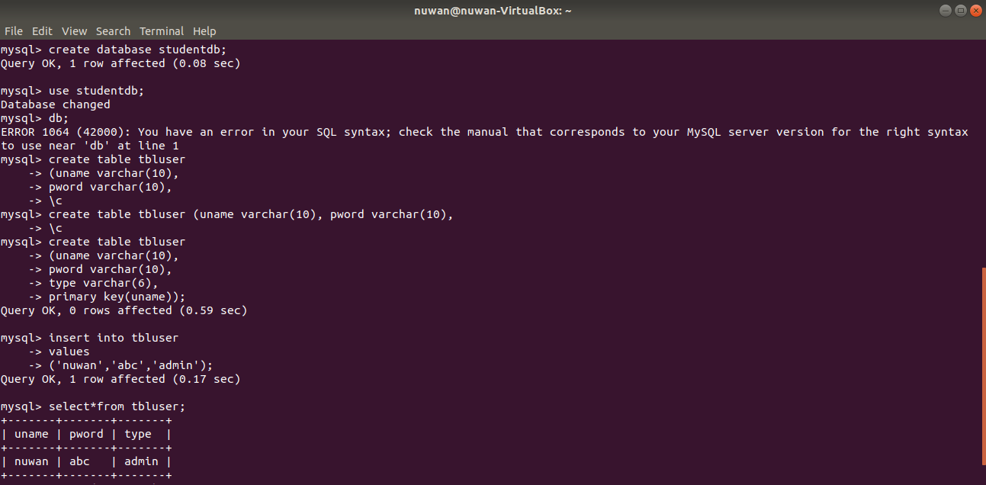4) Now I copy my PHP files and past to the Web Directory which is required for storing the data of our virtual host.

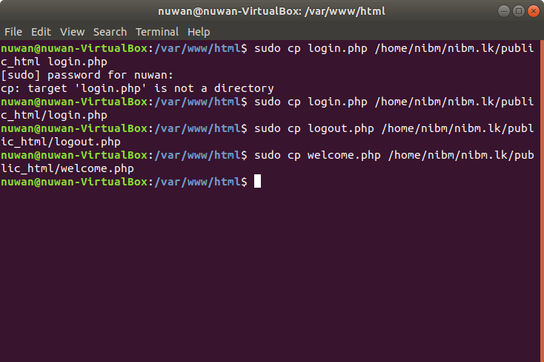

5) Now I open up web browser and point it to [www.nibm.lk/login.php](http://www.nibm.lk/login.php)

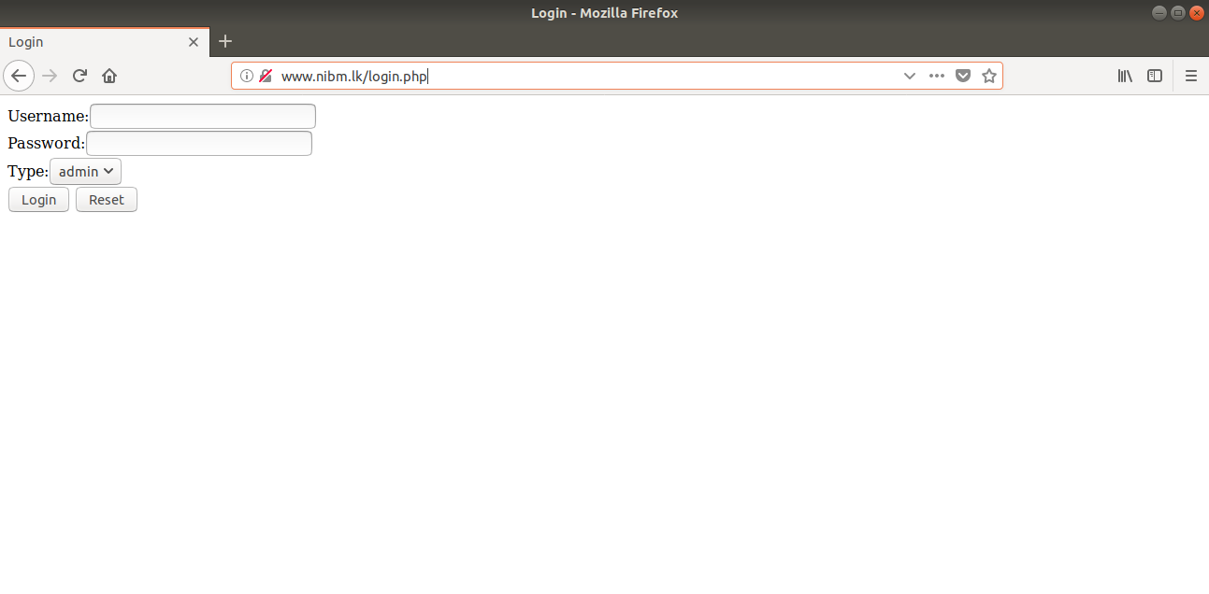

6) Now I am checking the form giving wrong inputs. In this case I am selecting the wrong user type.

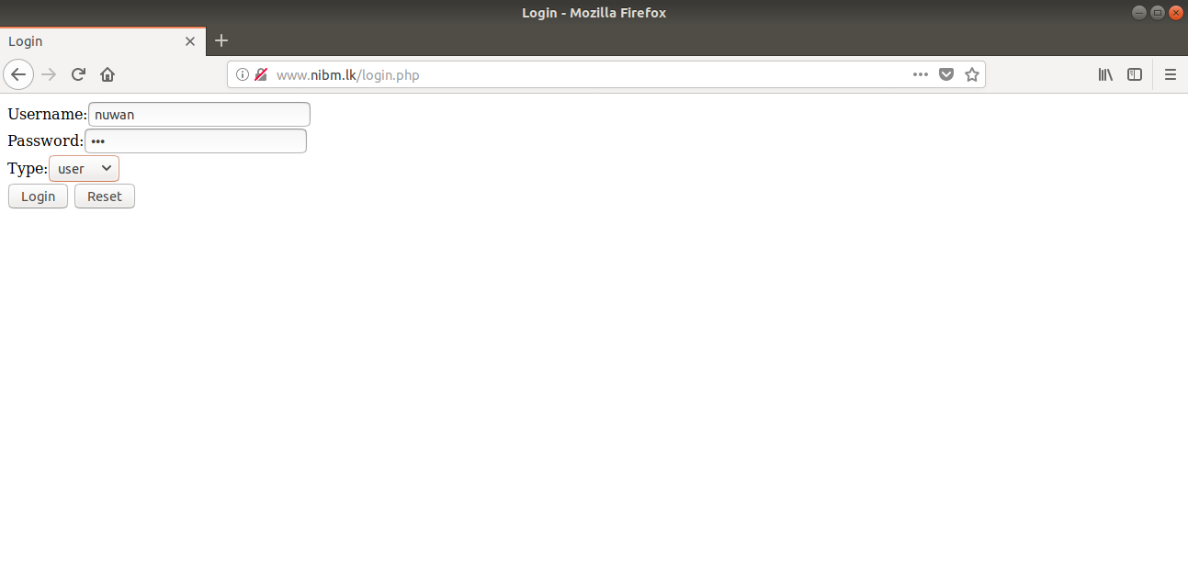

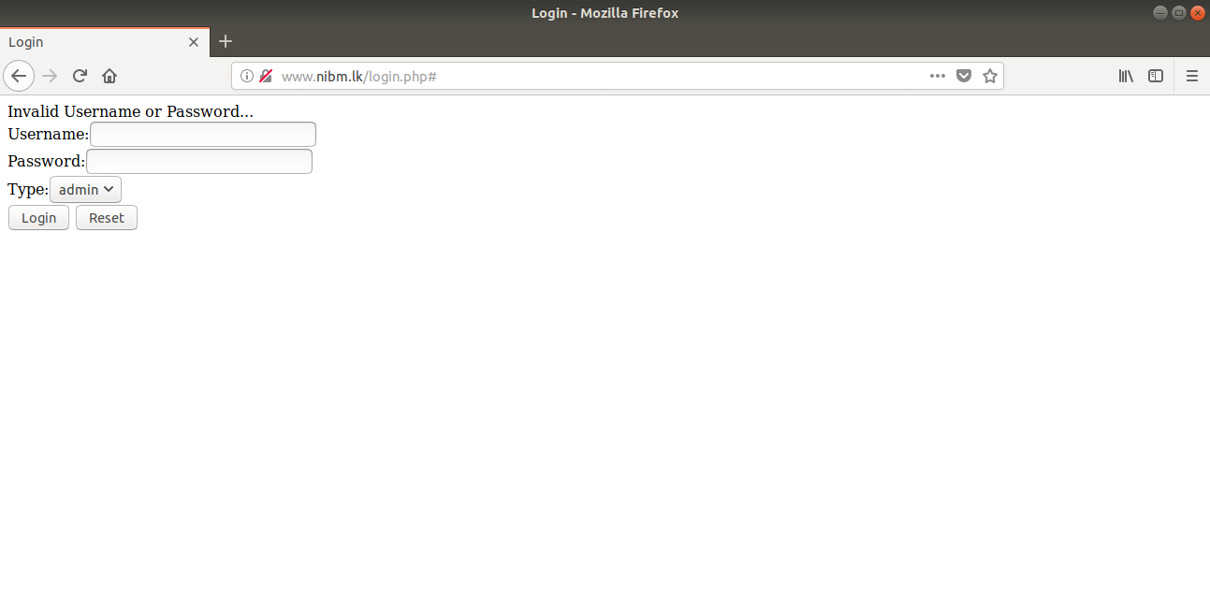

7) Now I am giving correct inputs. You can see login is successfully.

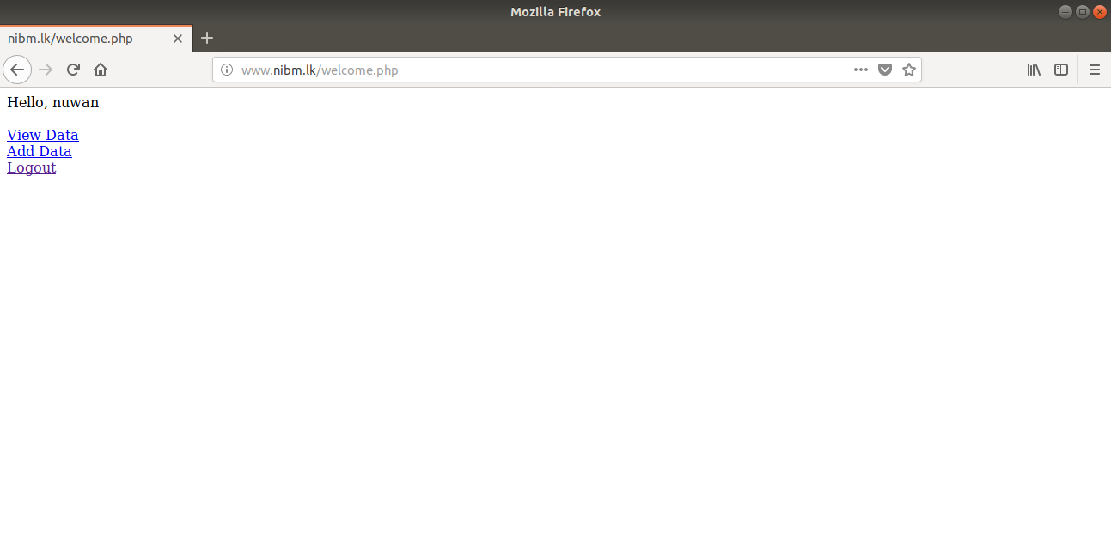

Thank you.